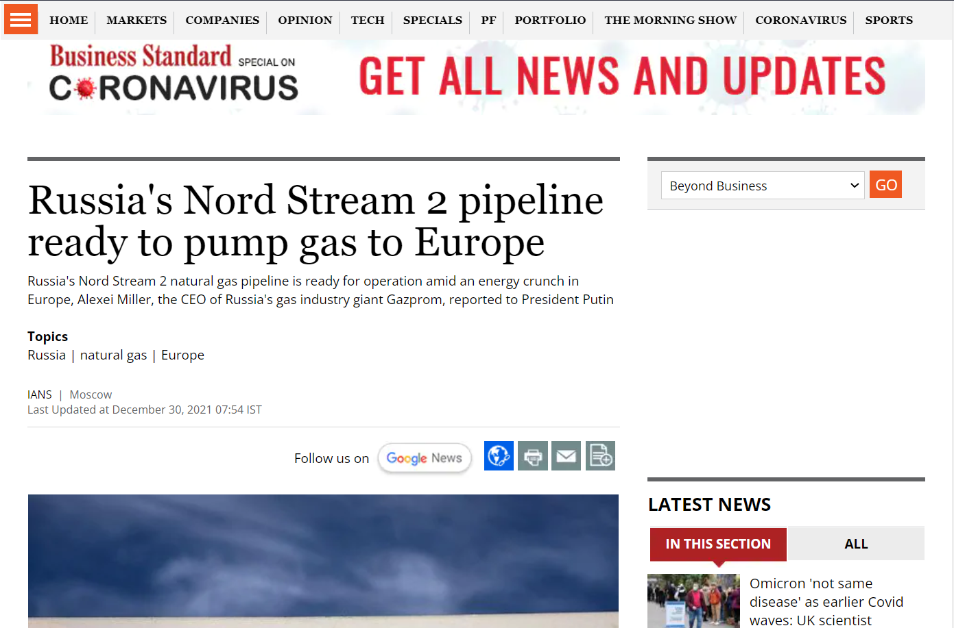
NORD STREAM 2, FROM A COMMERCIAL PROJECT TO A GEOPOLITICAL TOOL

It’d allow a direct supply in the natural gas from Baltic Sea to Germany. The gases exported would be cheaper and route would be smaller
No, other European country would be involved
It has received a strong opposition from USA and the most of Europe.
They say that it’d give Russia, a leverage on the negotiating table and undermine European security and democracy.
The pipelining of NS2 began in 2015, aiming to double the capacity of NS1

In 2019, Trump passed a law to impose sanctions to countries involved in NS2.
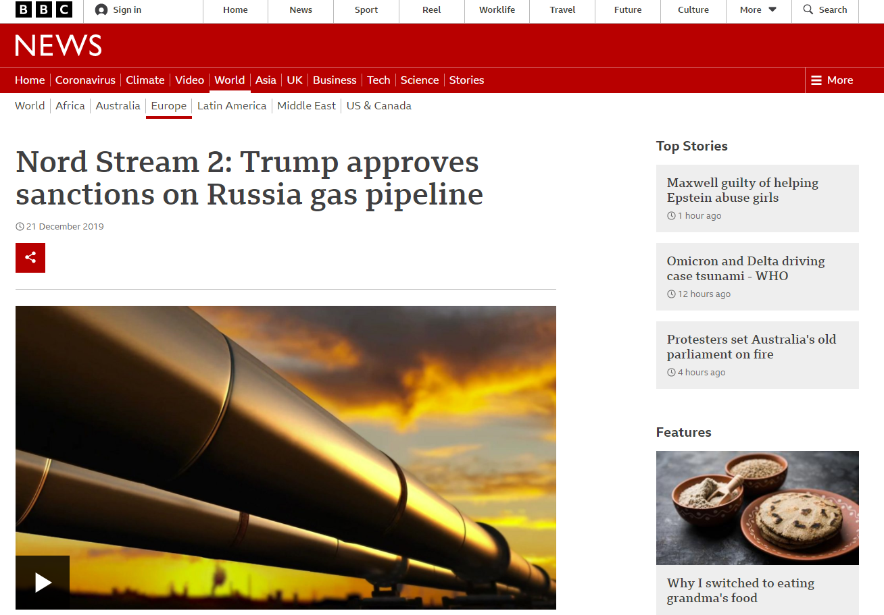

Because this would undermine USA’s influence in Europe and present a challenge to its LNG exports in Europe.
In May 2021, Biden administration, waivered NS2 project, to re-establish trust between USA and Germany

Already Europe is facing shortage of energy and the prices of limited fossil fuels have risen by almost 2 times.

Meanwhile, tensions have been on peak between Russia and NATO over Ukraine issue and
The pipeline, however, has been lying idle, pending a go-ahead from Germany and the European Union.

#russia #naturalgas #europe

